BIRDS CANADA

Cooperator Health & Safety Information and Commitment Form

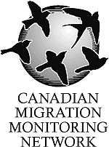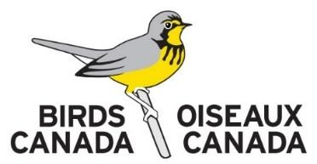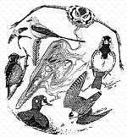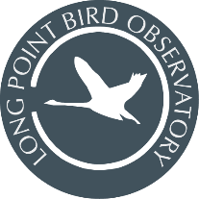

Return to: Birds Canada c/o Long Point Bird Observatory, P.O. Box 160, Port Rowan, ON Canada N0E 1M0. 519586-3531 lpbo@birdscanada.org | www.birdscanada.org/lpbo

This form must be completed by all staff and guests staying at Starling House, Old Cut Research Station, or other
Birds Canada facilities. To ensure the safety and well-being of all participants, we are required to collect certain personal information. This is necessary for health and safety planning, and to meet insurance requirements in case
of an emergency. Your information will be handled with care, kept confidential, and only shared with those directly responsible for your safety and support during your stay. This form will be distributed for completion upon booking.

Name: | Citizenship:
Address:
City: | Province/State:
Postal or Zip Code: | Country:
Phone: | Email:
Emergency Contact Name: | Phone No.:
Do you have a valid driver's license (circle one)? Yes No  Do you plan to bring a vehicle to LPBO (circle one)? Yes No | Province/State/Country: -----
Do you have up to date lifesaving, CPR, or first-aid training?
Do you have any physical or mental health conditions requiring treatment, medical supervision, or that may be of concern to staff responsible for your safety in very remote locations? If yes, please provide details. Due to the remote nature of some of our locations (The Tip, Breakwater) where emergency medical assistance may be delayed by several hours, we ask that you inform us of any medical conditions that may jeopardize your safety while in a remote wilderness setting or of any mental health conditions that may prevent you from comfortably living in a remote setting or a group-living situation. Disclosing this information is voluntary and will only be shared with individuals responsible for your safety.

Do you have any allergies, dietary preferences or restrictions?

Are you prepared to use a meal plan at remote stations that is dependent on a grocery run every 1-2 weeks? Please initial or put yes or no

Are you prepared to share a bedroom with individuals of different genders? Accommodations at Old Cut are prioritized by gender, but all remote stations involve sleeping in a shared loft. Please initial or put yes or no

Are you prepared to share a bedroom with others (rooms at Old Cut range from 2-4 people; the lofts at the Tip and Breakwater range from 3-6 people)? Please initial or put yes or no

I agree to share in the preparation of boat trips, surveys, and other logistical needs to support remote stations? Please initial

I agree to share in routine chores and maintenance of the facilities and equipment. Please initial.

I have read and agree to the accommodation expectations outlined in the Starling House Fact Sheet or Long Point Bird Observatory Living Guide. Please initial.

Comments or other important information.

By signing this form, you confirm that you have provided all necessary information to help ensure a safe work environment for yourself and fellow cooperators. You also acknowledge that you have read, and understand, and
agree to follow all expectations outlined in this Guide, as well as any related program protocols and health and safety procedures. Failure to adhere to Birds Canada’s expectations regarding facility care, health and safety, or respectful conduct may result in dismissal from the program and/or facilities without reimbursement.
Signature: | Date:

