**Birds Canada**

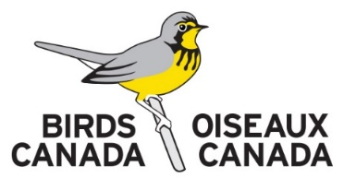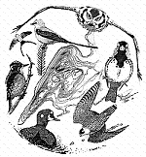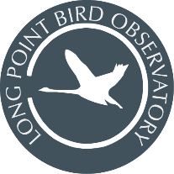**Cooperator Health & Safety Information and Commitment Form**

Return to: Birds Canada c/o Long Point Bird Observatory, P.O. Box 160, Port Rowan, ON Canada N0E 1M0. 519-586-3531 [lpbo@birdscanada.org](mailto:lpbo@birdscanada.org) | [www.birdscanada.org/lpbo](http://www.birdscanada.org/lpbo)

This form must be completed by all staff and guests staying at Starling House, Old Cut Research Station, or other Birds Canada facilities. To ensure the safety and well-being of all participants, we are required to collect certain personal information. This is necessary for health and safety planning, and to meet insurance requirements in case of an emergency. Your information will be handled with care, kept confidential, and only shared with those directly responsible for your safety and support during your stay. *This form will be distributed for completion upon booking.*

|  |  |
| --- | --- |
| Name: | Citizenship: |
| Address: | |
| City: | Province/State: |
| Postal or Zip Code: | Country: |
| Phone: | Email: |
| Emergency Contact Name: | Phone No.: |
| Do you have a valid driver's licence? No (although, as of the workshop, I will have my G1 Permit) | Province/State/Country: ----- |
|  | |
| Do you have up to date lifesaving, CPR, or first-aid training? | |
| Do you have any physical or mental health conditions requiring treatment, medical supervision, or that may be of concern to staff responsible for your safety in very remote locations? If yes, please provide details. Due to the remote nature of some of our locations (The Tip, Breakwater, Thunder Cape) where emergency medical assistance may be delayed by several hours, we ask that you inform us of any medical conditions that may jeopardize your safety while in a remote wilderness setting. Disclosing this information is voluntary and will only be shared with individuals responsible for your safety. | |
| Do you have any allergies, dietary preferences or restrictions? | |
| Are you prepared to share a bedroom with others? | |
| I agree to share in routine chores and maintenance of the facilities and equipment. *Please initial.* | |
| I have read and agree to the accommodation expectations outlined in the accompanying living guidelines. *Please initial.* | |
| Comments or other important information. | |
| *By signing this form, you confirm that you have provided all necessary information to help ensure a safe work environment for yourself and fellow cooperators. You also acknowledge that you have read, and understand, and agree to follow all expectations outlined in this Guide, as well as any related program protocols and health and safety procedures. Failure to adhere to Birds Canada’s expectations regarding facility care, health and safety, or respectful conduct may result in dismissal from the program and/or facilities without reimbursement.* | |
| Signature: | Date: |