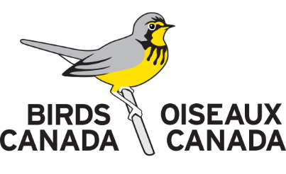
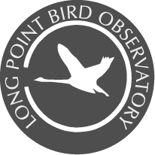
____________________________________Long Point Bird Observatory
Volunteer Field Biologist – Application

Volunteering at LPBO requires communal living, long hours, physical exertion, enduring bugs, heat and cold, irregular supplies of fresh food, rustic and isolated living conditions, and boating on rough water. Volunteers should be the kind of people who thrive in exciting and challenging field conditions and have a passion for birds, natural history, wild weather, simple living and learning. If you are interested in applying for a volunteer position please complete the following form and email it along with your resume or CV to lpbo@birdscanada.org

Name: |  |  |  | Citizenship:
Address:

City: |  |  | Province/State:
Postal/Zip Code: |  |  | Country:
Phone: |  |  | Email:
Present Occupation:

Emergency Contact Name: |  |  |  | Phone:
 |  |  |  | Email:
Education (highest degree completed or current status):
Have you volunteered at LPBO before? ___ No ___ Yes |  |  |  | Years:
Have you volunteered at another Canadian Migration Monitoring Network Station? ___ No ___ Yes |  |  |  | CMMN Stations:
Application for:
___ Tree Swallow Project (May-early July)
___ Breeding Bird Census (late May-June)
___ Spring Migration Monitoring (April 1-June 15)
___ Fall Migration Monitoring (August 15-November 15)
___ Latin American Training Program (August 15-November 15)
Alternative period if first choice is unavailable:
What specific dates are you available for (1 month minimum preferred)?
What percentage of eastern North American birds can you identify by sight:
___ <25% ___ 26-50% ___ 51-75% ___ >75%
What percentage of eastern North American birds can you identify by sound:
___ <25% ___ 26-50% ___ 51-75% ___ >75%
Do you hold a current banding permit?  ___ No ___ Yes |  |  |  | Country:
 |  |  |  | Permit Level:
Do you have a North American Banding Council Certification? ___ No ___ Trainer ___ Bander
How many birds have you extracted from mist nets (estimate)?
How many birds have you banded (estimate)? | Number of Species Banded |  |  |  | Number of Individuals Banded
Passerines
Owls
Diurnal raptors
Shorebirds
Other birds
What other biological field experience do you have?

Please describe why you think you will be helpful to LPBO:

What banding, ornithological or other biological organizations are you a current member of?

Do you have a valid driver's licence? ___ No ___ Yes
Do you have a valid Pleasure Craft Operators card? ___ No ___ Yes
Do you have experience with: ___ Bandit ___ Band Manager ___ Microsoft Excel
Do you have current life-saving certification? ___ No ___ Basic First-Aid ___ CPR
Are you physically fit? ___ No ___ Yes
Do you have good eyesight? ___ No ___ Yes
Do you have good hand/eye coordination? ___ No ___ Yes
Are you emotionally fit? ___ No ___ Yes
Are you prepared to share in daily data entry, cooking and routine maintenance chores as outlined in the Volunteer Fact Sheet? ___ No ___ Yes
Are you willing to share a bedroom with other volunteers of both sexes? ___ No ___ Yes
Are you willing and able to live in a remote location, in rustic conditions with no phone or email access for weeks at a time? ___ No ___ Yes
Are you willing to relocate between field stations on short notice when required? ___ No ___ Yes
Do you have any medical conditions?  ___ No ___ Yes |  | Please specify:
Where did you find out about LPBO volunteer opportunities?

Reference 1 Name: |  | Position:
 |  | Phone:
 |  | Email:
Reference 2 Name: |  | Position:
 |  | Phone:
 |  | Email:
Reference 3 Name: |  | Position:
 |  | Phone:
 |  | Email:
Applicant’s Signature:
Date:
Would you like us to forward your application to other members of the Canadian Migration Monitoring Network if space is not available at LPBO? ___ No ___ Yes

